# Brainstorm

**& idea prioritization**

### Use this template in your own brainstorming sessions so your team can unleash their imagination and start shaping concepts even if you're not sitting in the same room.

it will automatically moniter all the activites of feld

iot provide integrated platform to farmers

Data stored in cloud it will be usefull far farmers to see the activities of the crop

**Before you collaborate**

##### A little bit of preparation goes a long way with this session. Here’s what you need to do to get going.

**10 minutes**

###### Team gathering

Define who should participate in the session and send an invite. Share relevant information or pre-work ahead.

###### Set the goal

Think about the problem you'll be focusing on solving in the brainstorming session.

###### Learn how to use the facilitation tools

Use the Facilitation Superpowers to run a happy and productive session.

**1**

**Define your problem statement**

##### What problem are you trying to solve? Frame your problem as a How Might We statement. This will be the focus of your brainstorm.

**5 minutes**

Ensure digital and it awarness

**TIP**

Add customizable tags to sticky notes to make it easier to find, browse, organize, and categorize important ideas as themes within your mural.

**PROBLEM**

Most of the rural area people can't implement the IOT devices because of they don't know about the device uses and it is difcult to use it

**2**

**Brainstorm**

Write down any ideas that come to mind that address your problem statement.

**10 minutes**

**Person 1**

Within a minute it can alert the farmer

It is an automation device it can reduce the work

It can notitfy the problems that occur in the fled

**TIP**

You can select a sticky note and hit the pencil [switch to sketch] icon to start drawing!

**Person 2**

It can be easy to use by controlling the device from home

serve variety of electronic services to villages

it controls various parameters on their felds

it can fullfll the customers needs

**3**

**Group ideas**

##### Take turns sharing your ideas while clustering similar or related notes as you go. Once all sticky notes have been grouped, give each cluster a sentence-like label. If a cluster is bigger than six sticky notes, try and see if you and break it up into smaller sub-groups.

**20 minutes**

it includes to increase economic impact

By educating them about the iot device

Connect skilling interventions to market

To encourage digital and fnancial inclusivity

**4**

**Prioritize**

Your team should all be on the same page about what's important moving forward. Place your ideas on this grid to determine which ideas are important and which are feasible.

**20 minutes**

Help farmers for intensive agriculture

Connect skilling interventions to market

By educating them about the iot device

**After you collaborate**

You can export the mural as an image or pdf to share with members of your company who might find it helpful.

**Quick add-ons**

###### Share the mural

**Share a view link** to the mural with stakeholders to keep them in the loop about the outcomes of the session.

###### Export the mural

Export a copy of the mural as a PNG or PDF to attach to emails, include in slides, or save in your drive.

It can show the fertility of the land.

so farmer can use the required fertilizer

It can notitfy the problems that occur in the fled

**10 minutes** to prepare

Suitable for all types of soil

Saving in labour and feld preparation cost

For using various smart agricultural gadgets, farmers have gained better control over the provess

**1 hour** to collaborate

**2-8 people** recommended

###### [Open article](https://support.mural.co/en/articles/2113740-facilitation-superpowers)

**Members of Ideation Process: Team Leader: Tamilselvam A**

**Team Members : Siva G**

**Key rules of brainstorming**

it can fullfll the customers needs

it can store all the datas in the cloud

Improved and new technolog will help farmers in effevitve way

To run an smooth and productive session

#### Keep moving forward

###### Strategy blueprint

Define the components of a new idea or strategy.

###### [Open the template](https://app.mural.co/template/e95f612a-f72a-4772-bc48-545aaa04e0c9/984865a6-0a96-4472-a48d-47639307b3ca)

**Customer experience journey map**

it can show the fertility of the land.

so farmer can use the required fertilizer

Siddeshwaran R

Help farmers for intensive agriculture

Saving in labour and feld preparation cost

Venkatachalam R

Vishnu S

Stay in topic.

Defer judgment.

Encourage wild ideas.

Listen to others.

#### Importance

it can show the fertility of the land.

so farmer can use the required fertilizer

Within a minute it can alert the farmer

saving in labour and feld preparation cost

High accuracy of feld encryption

It will automatically moniter all the activites of feld

If each of these tasks could get

It can be easy to use by controlling the device from home

Understand customer needs, motivations, and obstacles for an experience.

###### [Open the template](https://app.mural.co/template/b7114010-3a67-4d63-a51d-6f2cedc9633f/c1b465ab-57af-4624-8faf-ebb312edc0eb)

This application or software will suggest every time to acces the whole system

Improved and new technolog will help farmers in effevitve wa

To encourage digital and fnancial inclusivity

Go for volume. If possible, be visual.

By educating them about iot device

**Person 3**

Connect skilling interventions to market

This application or software will suggest every time to acces the whole system

## 

It can be easy to use by controlling the device from home

secured cloud based server created to store data

**Person 4**

saving in labour and feld preparation cost

Ensure digital and it awarness

It includes to increase economic impacdt

done without any difficulty or cost, which would have the most positive impact?

**TIP**

Participants can use their cursors to point at where sticky notes should go on the grid. The facilitator can confirm the spot by using the laser pointer holding the **H key** on the keyboard.

High accuracy of feld encryption

###### Strengths, weaknesses, opportunities & threats

Identify strengths, weaknesses, opportunities, and threats (SWOT) to develop a plan.

High accuracy of feld encryption

|  |  |
| --- | --- |
|  |  |
|  |  |

###### [Open the template](https://app.mural.co/template/6a062671-89ee-4b76-9409-2603d8b098be/ca270343-1d54-4952-9d8c-fbc303ffd0f2)

It includes to increase economic impact

[**Share template feedback**](https://muralco.typeform.com/to/CiqaHVat?typeform-source=app.mural.co)

For using various smart agricultural gadgets, farmers have gained better control over the provess

Balancing the need of devices to ensure the device effectively

Software interface will be understandabe

By educating them about the iot device

Easy for the users

[**Share template feedback**](https://muralco.typeform.com/to/CiqaHVat?typeform-source=app.mural.co)

Suitable for all types of soil

**Feasibility**

Regardless of their importance, which tasks are more feasible than others? (Cost, time, effort, complexity, etc.)

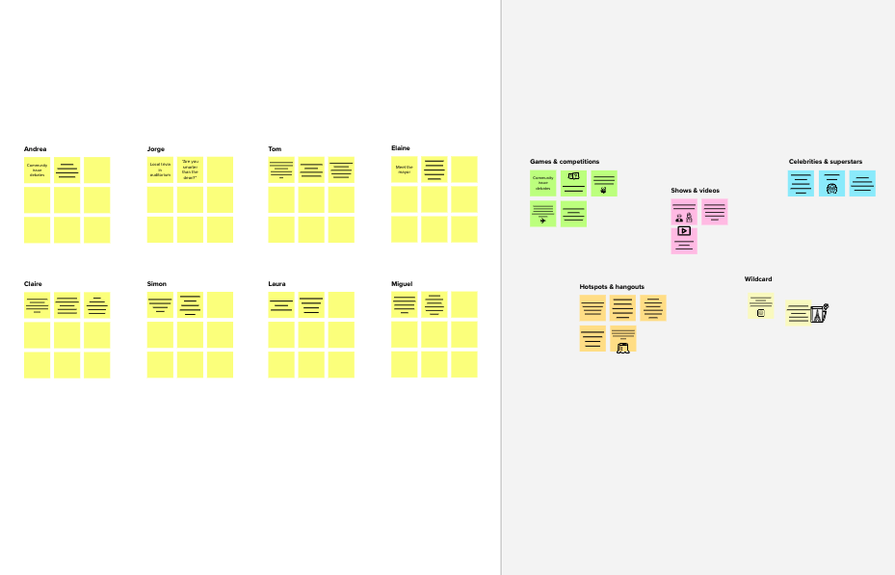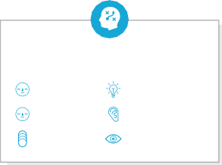

**Template**

**Need some inspiration?**

See a finished version of this template to kickstart your work.

[**Open example**](https://app.mural.co/template/e5a93b7b-49f2-48c9-afd7-a635d860eba6/93f1b98d-b2d2-4695-8e85-7e9c0d2fd9b9)